2021 AFEP Annual Review
January 10-12, 2022
  - Agenda
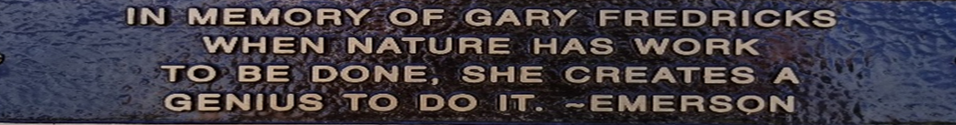
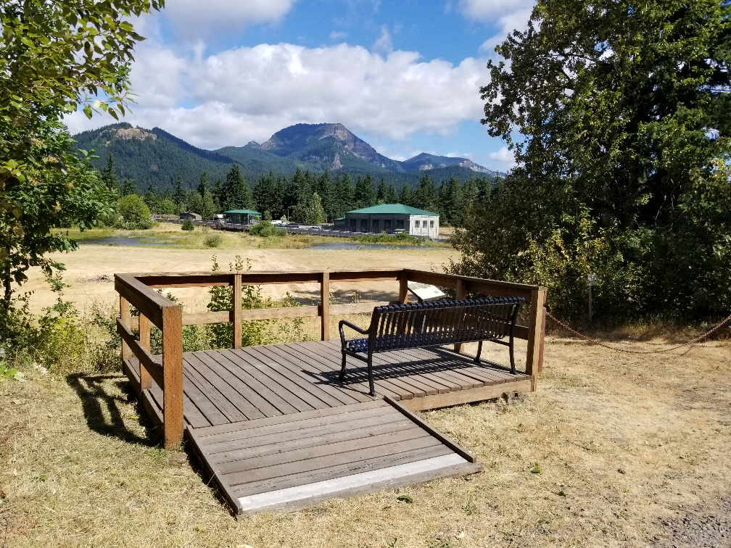

Monday AM: Plenary (AFEP2021_Plenary.mp4)

http://pweb.crohms.org/tmt/documents/FPOM/2010/2021_AFEP/AFEP2021_Plenary.mp4

(0:00) Jake Macdonald (USACE) - Welcome & introduction

(5:20) Regional news:
- (5:20) Trevor Conder in remembrance of Gary Fredricks 102_Conder_Gary Fredricks Memorial
- (16:15) Brad Trumbo in remembrance of Marvin Shutters
- (23:00) Jeff Fryer in remembrance of Dr. Kim Hyatt

(32:00) Tim Dykstra, Northwestern Division (USACE) – Opening remarks

(40:45) Charles Seaton (CRITFC) - Coastal Margin Observation and Prediction (CMOP) Program 104_Seaton_CMOP_overview_AFEP

Monday PM: Adult Fish Passage (AFEP2021_Adult Fish Passage.mp4)

http://pweb.crohms.org/tmt/documents/FPOM/2010/2021_AFEP/AFEP2021_Adult%20Fish%20Passage.mp4

(0:00) Karl Anderson (USACE) Speaker Introductions

(1:00) Kenneth Ham (PNNL) – Evaluation of a Surface Spill Operation to Return Adult Steelhead Overshoots Downstream of McNary Dam 202_Ham_2020_2021_MCN_Steelhead_Overshoots

(21:30) Chris Peery (USACE) - A summary of fishway water temperatures and fish passage at Walla Walla District dams in 2021 203_ Peery_Fishway Temps
(54:30) Jeff Fryer (CRITFC) – The CRITFC adult salmonid sampling and tagging program at the Bonneville Dam Adult Fish Facility with insights on Sockeye upstream survival in the high temperature years of 2015 and 2021

(1:16:45) Jake Macdonald (USACE) – Adult lamprey passage improvements at Corps dams 205_Macdonald_Adult Lamprey Passage Improvements

Tuesday AM: Juvenile Fish Passage (AFEP2021_JuvenileFishPassage.mp4)

http://pweb.crohms.org/tmt/documents/FPOM/2010/2021_AFEP/AFEP2021_JuvenileFishPassage.mp4

(0:00) Karl Anderson (USACE) Speaker Introductions (10 min)

(1:00) Steve Smith (NOAA) – Juvenile Salmonid Reach Survival Estimates from PIT-Tagged Fish, 2021 Update

(34:30) Steve Smith (NOAA) – Seasonal Effects of Transporting Fish from the Snake River, 2021 Update 302_Smith_Smolt Survival and Transportation

(50:00) Rebecca Buchanan (UW) – PIT-Tag Detections at Dams in the Context of Spill and Precision of Survival Estimates

(1:16:45) Karl Anderson (USACE) – Juvenile lamprey passage improvements and RM&E plan

(1:30:30) Ken Tiffan (USGS) - Monitoring Native, Resident Nonsalmonids for the Incidence of Gas Bubble Trauma Downstream of Snake and Columbia River Dams, 2021

Tuesday PM: Technology (AFEP2021_Technology.mp4)

http://pweb.crohms.org/tmt/documents/FPOM/2010/2021_AFEP/AFEP2021_Technology.mp4

(0:00) Karl Anderson (USACE) Speaker Introductions

(1:45) Gabriel Brooks (NOAA) – Advancements in PIT detection technology: Flexible cable PIT trawl, PIT detection on pile dikes, TSW detector, etc.

(27:00) Daniel Deng (PNNL): Miniature Radio-Frequency Transmitters and 3D Tracking

(47:45) Aljon Salalila (PNNL): Autonomous real-time water monitoring system

(1:06:45) Daniel Deng for Jayson Martinez (PNNL): Real-time underwater acoustic telemetry system

Wednesday AM: Estuary Habitat (AFEP2021_Estuary.mp4)

http://pweb.crohms.org/tmt/documents/FPOM/2010/2021_AFEP/AFEP2021_Estuary.mp4

(0:00) Chanda Littles (USACE) – Introduction to CEERP and speakers

(11:30) Regan McNatt (NOAA) – Role of the estuary in larger salmon recovery

(30:00) Curtis Roegner (NOAA) – Salmon prey flux

(51:30) Nichole Sather (PNNL) – Action Effectiveness Monitoring and Research of Dredged Material Placement at Woodland Islands

(1:16:45) Sarah Kidd (LCEP) – BPA sponsored mainstem habitat restoration and monitoring

(1:37:00) Ryan Woolbright/Doug Swanson (USACE) – Corps assessment of future BUDM opportunities in the LCR

Wednesday PM: Predation (AFEP2021_Predation.mp4)

http://pweb.crohms.org/tmt/documents/FPOM/2010/2021_AFEP/AFEP2021_Predation.mp4

(0:00) Jake Macdonald (USACE) - Speaker Introductions

(3:45) Kyle Tidwell (USACE) – Pinniped hazing assessment

(19:30) Eric Winther (WDFW) - Pikeminnow predation at the dams

(38:30) Bob Cordie (USACE) – Predation deterrence at the mainstem dams 604_Cordie_Predation at Dams
(1:03:20) Jake Macdonald (USACE) – Implementation of the Corps’ avian predator management plans in the Columbia River Estuary 605_Macdonald_AvianPredation
(1:12:45) Kyle Tidwell (USACE) – Avian predator management on ESI and upland dredge placement sites in the estuary

(1:28:40) James Lawonn (ODFW) – Double-crested cormorant population monitoring in the estuary

(1:36:30) Nate Banet (RTR) - Per capita (per breeding pair) and colony-wide effects of predation by DCCO breeding on the Astoria-Megler (A-M) Bridge in 2021 (funded by BPA) Banet_AFEP_AMB_Predation_Talk_011222_FINAL

(2:01:30) Bill Sharp (YN) – Gull management at Miller Rocks 609_Sharp_MillerRocks

(2:17:30) David Trachtenbarg (USACE) – Evaluation of John Day pool operation to delay Caspian tern nesting on the Blalock Islands 610_Trachtenbarg_JDA_2021_Summary
(2:31:40) Tim Lawes (OSU) - Caspian Tern regional assessment (funded by USFWS)

(2:52:00) Allen Evans (RTR) – System-wide effects of predation by terns, cormorants, gulls, and pelicans on Upper Columbia River steelhead in 2021 (funded by BPA and Grant County PUD via the Priest Rapids Coordinating Committee) 612_Evans_2021 Systemwide Effect of Predation

(3:20:20) Tom Skiles (CRITFC) - Regional Avian Predation Forum – Goals and Objectives

